Share the Plate. Each month one-half of the loose currency in the offering plate is donated to a cause with a local presence which advances important principles of Unitarianism. This month’s recipient is Community Meals. The main task of this organization is to provide a weekly meal on Saturdays at First Baptist Church. Three to four times a year our church cooks and serves the meal for about 250 people living in our neighborhood.

Change for Change. Each week generous people put change in the collection plate. This change goes to our Sunday School youth who decide where the money can be best utilized. In the past they have contributed to Community Meals and International Bridges for Justice. This year youth have identified the recipient as Neighborhood Ministry Team, which purchases bus tickets, and food cards and provides blessings bags to people who come to our church requesting help. Your change makes a difference! Thank you for your generosity!

Rev. Frank Rivas, Minister (minister@firstuuomaha.org)
Rev. Ron Knapp, Minister Emeritus
Jan Wilson, Director of Religious Education (dre@firstuuomaha.org)
Carrie Helmberger, Membership Coordinator (coordinator@firstuuomaha.org)
Catharine Dixon, Church Administrator (admin@firstuuomaha.org)
Jenny Hastings, Nursery Coordinator
Patricia Will, Organist
William Miller, Choir Director
Elizabeth Kelly, Choir Accompanist
Stan Harper, Pianist
Robert Medrano, Custodian

3114 Harney Street

Omaha, Nebraska 68131
(402) 345-3039
www.firstuuomaha.org

First Unitarian Church of Omaha

Order of Worship

April 2, 2017

10:30 A.M.

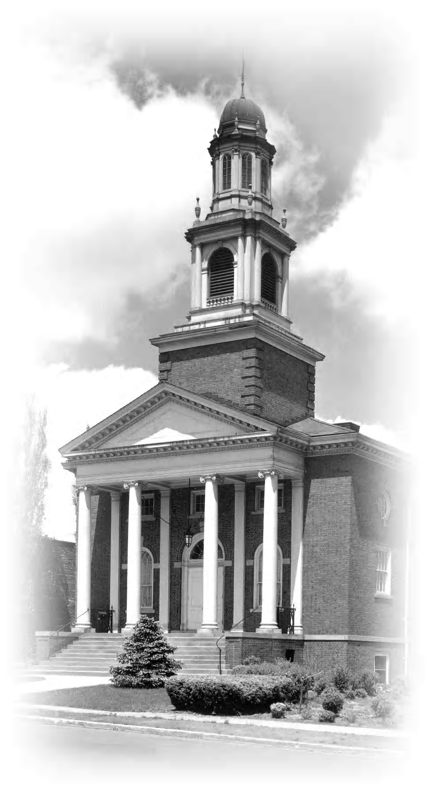

The First Unitarian Church of Omaha strives to be a welcoming, liberal religious community with traditions of reason and tolerance, which are reflected in how we live our lives. We are committed to introducing our youth to the breadth of religious thought and encouraging them to responsibly discern their own spiritual paths. We promote spiritual growth, social justice and sustainable living to affect positive change in our society and ourselves.

Order of Worship
April 2, 2017
10:30 A.M.
GATHERING
BELLSOUND
PRELUDE “Be Thou My Vision” — Irish Folk Tune arr. Wood
WELCOME
STORY FOR ALL AGES Kate Wiig
* LIGHTING THE CHALICE
At times our own light goes out and is rekindled by a spark from another person. Each of us has cause to think with deep gratitude of those who have lighted the flame within us. — Albert Schweitzer
* SINGING THE CHILDREN TO THEIR CLASSES
Go now in peace. Go now in peace.
May the Spirit of Love surround you,
Everywhere, everywhere you may go.
ANNOUNCEMENTS Maria Wallace
JUSTICE PULPIT Elaine Wells
Minister: It is the church that assures us that we are not struggling for justice
on our own but, as members of a larger community.
Congregation: The religious community is essential, for alone our vision is too narrow to see all that must been seen, and our strength too limited to do all that must be done.
Minister: Together, our vision widens and our strength is renewed.
OFFERTORY ”Fantasia” — Pachelbel
(*Indicates congregation stands as they are able.)

REFLECTING
CHORAL INTROIT “Filled with Loving Kindness” — Hayes
A MOMENT OF SILENCE concluded with a bellsound
DOXOLOGY (#123) “Spirit of Life”
FIRST LESSON — Lao Tsu
SECOND LESSON — William Staford
CHORAL ANTHEM “Wind Beneath My Wings” — arr. Emerson
SERMON “Roots Hold Me Close” Rev. Frank Rivas

AFFIRMING
* HYMN (#298) “Wake, Now My Senses”
* BENEDICTION —from Mary Oliver
CHORAL BENEDICTION “Lean On Me” — Withers
POSTLUDE “Toccata (on St. Anne)” — Young

Organist: Patricia Will
Choir Director: William Miller
Choir Accompanist: Judi Torneten

The Share the Plate beneficiary for the month of April is Community Meals.
The Change for Change beneficiary is the Neighborhood Ministry Team.

