Share the Plate. Each month one-half of the loose currency in the offering plate is donated to a cause with a local presence which advances important principles of Unitarianism. This month’s recipient is OTOC (Omaha Together One Community), a local interfaith organization of which First Unitarian is a member. We encourage you to learn more about OTOC by visiting their website www.otoc.org
Change for Change. Each week generous people put change in the collection plate. This change goes to our Sunday School youth who decide where the money can be best utilized. In the past they have contributed to Community Meals and International Bridges for Justice. This year youth have identified the recipient as Neighborhood Ministry Team, which purchases bus tickets, and food cards and provides blessings bags to people who come to our church requesting help. Your change makes a difference! Thank you for your generosity!

Rev. Frank Rivas, Minister (minister@firstuuomaha.org)
Rev. Ron Knapp, Minister Emeritus
Jan Wilson, Director of Religious Education (dre@firstuuomaha.org)
Carrie Helmberger, Membership Coordinator (coordinator@firstuuomaha.org)
Catharine Dixon, Church Administrator (admin@firstuuomaha.org)
Jenny Hastings, Nursery Coordinator
Gale Callaghan, Nursery Aide
Patricia Will, Organist
William Miller, Choir Director
J. Gawf, Choir Accompanist
Stan Harper, Pianist
Robert Medrano, Custodian

3114 Harney Street

Omaha, Nebraska 68131
(402) 345-3039
www.firstuuomaha.org

First Unitarian Church of Omaha

Order of Worship

November 19, 2017

10:30 A.M.

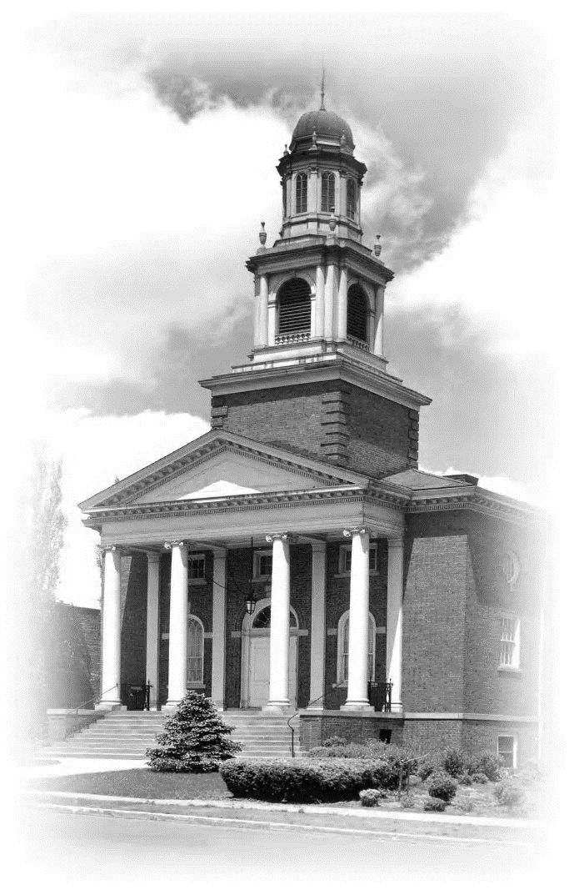

An inclusive community that listens, engages, inspires, and acts.

Order of Worship
November 19, 2017
10:30 A.M.
GATHERING
BELLSOUND
PRELUDE “Creator of the Stars of Night” — McCabe
WELCOME
STORY FOR ALL AGES Kate Wiig
* LIGHTING THE CHALICE
At times our own light goes out and is rekindled by a spark from another person. Each of us has cause to think with deep gratitude of those who have lighted the flame within us. — Albert Schweitzer
* SINGING THE CHILDREN TO THEIR CLASSES
Go now in peace. Go now in peace.
May the Spirit of Love surround you,
Everywhere, everywhere you may go.
ANNOUNCEMENTS Nellie Chenowith
OFFERTORY “Arietta” — Dello Joio
The Share the Plate beneficiary for the month of November is
OTOC (Omaha Together One Community).
The Change for Change beneficiary is the Neighborhood Ministry Team.

(*Indicates congregation stands as they are able.)

REFLECTING
THE PRACTICE OF MINDFULNESS
CHORAL INTROIT “Spirit of Life” — McDade
SPIRITUAL ODYSSEY Michael McAfee
Minister: To speak one’s truth is a sacred act.
Congregation: To hear another’s truth transforms us; it too is a sacred act.
Minister: In the speaking and the listening we become beloved community.
LESSON — Jane Wagner
CHORAL ANTHEM “For the Beauty of the Earth” —Rutter
SERMON “Crazy Enough to Give Thanks” Rev. Frank Rivas
AFFIRMING
* CLOSING HYMN (#349) “We Gather Together”
* BENEDICTION — from Francis of Assisi
CHORAL BENEDICTION “As We Leave This Friendly Place”
POSTLUDE “Sing to the Land of Harvest” — Eliot

Organist: Patricia Will
Choir Director: William Miller
Choir Accompanist: J. Gawf

