Share the Plate. Each month one-half of the loose currency in the offering plate is donated to a cause with a local presence which advances important principles of Unitarianism. This month’s recipient is Community Meals. The main task of this organization is to provide a weekly meal on Saturdays at First Baptist Church. Three to four times a year our church cooks and serves the meal for about 250 people living in our neighborhood.

Change for Change. Each week generous people put change in the collection plate. This change goes to our Sunday School youth who decide where the money can be best utilized. In the past they have contributed to Community Meals and International Bridges for Justice. This year youth have identified the recipient as Neighborhood Ministry Team, which purchases bus tickets, and food cards and provides blessings bags to people who come to our church requesting help. Your change makes a difference! Thank you for your generosity!

Rev. Frank Rivas, Minister (minister@firstuuomaha.org)
Rev. Ron Knapp, Minister Emeritus
Jan Wilson, Director of Religious Education (dre@firstuuomaha.org)
Carrie Helmberger, Membership Coordinator (coordinator@firstuuomaha.org)
Catharine Dixon, Church Administrator (admin@firstuuomaha.org)
Jenny Hastings, Nursery Coordinator
Patricia Will, Organist
William Miller, Choir Director
Elizabeth Kelly, Choir Accompanist
Stan Harper, Pianist
Robert Medrano, Custodian

3114 Harney Street

Omaha, Nebraska 68131
(402) 345-3039
www.firstuuomaha.org

First Unitarian Church of Omaha

Order of Worship

FEBRUARY 19, 2017

10:30 A.M.

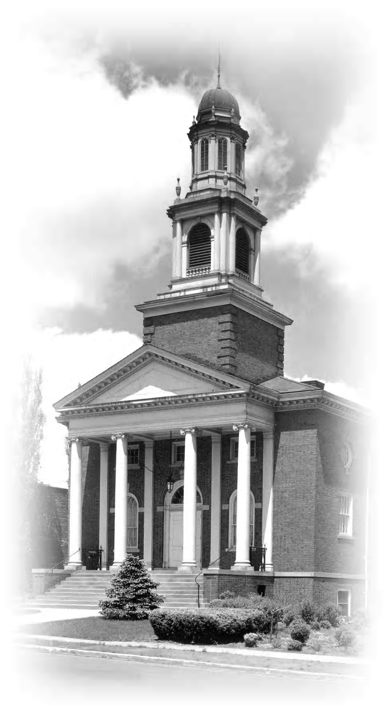

The First Unitarian Church of Omaha strives to be a welcoming, liberal religious community with traditions of reason and tolerance, which are reflected in how we live our lives. We are committed to introducing our youth to the breadth of religious thought and encouraging them to responsibly discern their own spiritual paths. We promote spiritual growth, social justice and sustainable living to affect positive change in our society and ourselves.

Order of Worship
February 19, 2017
10:30 A.M.
BELLSOUND
PRELUDE “Cantilena” — Rheinberger
OPENING WORDS Adam Dyer
* OPENING HYMN (#131) “Love Will Guide Us”
STORY FOR ALL AGES Kate Wiig
* LIGHTING THE CHALICE
At times our own light goes out and is rekindled by a spark from another person. Each of us has cause to think with deep gratitude of those who have lighted the flame within us. — Albert Schweitzer
* SINGING THE CHILDREN TO THEIR CLASSES
Go now in peace. Go now in peace.
May the Spirit of Love surround you,
Everywhere, everywhere you may go.
WELCOME & ANNOUNCEMENTS Nellie Chenoweth
CHORAL INTROIT “Spirit of Life” — McDade
OFFERTORY “Chanson” — Young

The Share the Plate beneficiary for the month of February is Community Meals.
The Change for Change beneficiary is the Neighborhood Ministry Team.

(*Indicates congregation stands as they are able.)

READING — Langston Hughes
CHORAL ANTHEM “Let There Be Peace On Earth” — Miller/Jackson
SERMON “Where is the Love?” Adam Dyer
* CLOSING HYMN (#1029) “Love Knocks and Waits for Us to Hear””
* CLOSING WORDS
CHORAL BENEDICTION “Bridge Over Troubled Water” — Simon
POSTLUDE “Fanfare” — Smith

Organist: Patricia Will
Choir Director: William Miller
Choir Accompanist: Elizabeth Kelly

